***The Jazz Age***

**Jed Rasula**

The expression, “the jazz age,” is one of the few aspects of the famous time it designates that can be traced with certainty, deriving as it does from F. Scott Fitzgerald, whose fame as a writer was affixed to the generic vista named in *Tales of the Jazz Age* (1922). Historians of jazz have been leery of the expression, and rarely even refer to Fitzgerald, who emphasized the *age*, not the “jazz.” As a period term, the jazz age has conformed fairly closely to the parameters set by Fitzgerald in a letter to Maxwell Perkins in 1931, extending “from the suppression of the riots of May Day 1919 to the crash of the stock market in 1929.” It has been understandably consigned to the “lost generation” of expatriate American writers, as Gertrude Stein identified them to Hemingway. The mid-century eminence of fiction by Fitzgerald and Hemingway—filled with hard-drinking characters lurching through life as an endless party—canonized the jazz age as an alcoholic binge contemporaneous with prohibition. The annals of jazz history confirm the diagnosis, most famously in the case of trumpeter Bix Beiderbecke. Frederick Turner’s novel *1929* (2003) is a vivid depiction of the alcoholic haze Bix shared with his “age,” revealing by contrast that actual “jazz age” novels consigned jazz to a strictly subordinate role, background music at best.

In his retrospective assessment, “Echoes of the Jazz Age” (1931), Fitzgerald associates jazz with sex and dancing foremost. As a signifier of libidinal excess, “jazz” was widely used independent of musical references. In fact, it was reported as a “futurist word” in a San Francisco newspaper in 1913, where its usage was traced back to sports (a baseball pitcher applied some “jazz” to the ball); and even after jazz was widely understood as a post-ragtime musical idiom, the word continued to mean *spice up*, *accentuate*, *bring to a boil*. Fitzgerald also associates it with “nervous stimulation, not unlike that of big cities behind the lines of a war.” In Europe, jazz bands achieved initial notoriety performing for troops on leave from the front in London and Paris. Furthermore, the military band convened at General Pershing’s request was staffed with African American musicians recruited by James Reese Europe, musical director for Vernon and Irene Castle before the war as they pioneered a worldwide vogue for “animal dances” like the foxtrot. These musicians had all been steeped in ragtime, and it was their generation that transformed rag rhythms into jazz—some of it in France during and after the war. The first prominent musical association with jazz came about when The Original Dixieland Jazz Band burst onto the commercial music scene in 1917. By 1922 it was commemorated as “The National Anthem of Civilization” in a play by J. Hartley Manners. The commercial impact of jazz—both music and social phenomenon—was much indebted to the then fairly young recording industry, and to commercial radio, which was launched after the war and exposed listeners to jazz through recordings and live broadcasts.

Because the word “jazz” consistently connoted novelty, its semantic slippage rendered it ubiquitous and imprecise even as it became a global phenomenon. In popular music it was first associated with “spasm bands” in which flash trumped music, and the principal musical characteristic was syncopated rhythm. As early as 1920 there were predictions this musical nuisance was about to disappear, and premature obituaries persisted in the press for the next decade. Gradually, however, “serious” musicians began to heed the latent potential of jazz. Bandleader Paul Whiteman famously sought to “made a lady” out of jazz at his Aeolian Hall concert in New York, February 12, 1924, which saw the premiere of George Gershwin’s *Rhapsody in Blue*. By that point, pundits had surmised an affinity between the emphatic rhythms of Stravinsky (going back to *The Rite of Spring*, 1913) and jazz, misleadingly labeling the Russian a “jazz composer.” There were many, however, who openly sought to incorporate jazz “touches” into concert scores, including *Le Création du Monde* by Darius Milhaud (who’d heard African American jazz bands in Harlem), and numerous compositions by George Antheil, Aaron Copland, Bohuslav Martinů, Erwin Schulhoff, among others. Classical composers found in jazz a practical way of being “modernistic” without following the cerebral precedent of Arnold Schoenberg and the Vienna School.

The jazz age meant, above all, being up to date. T. S. Eliot, Virginia Woolf and James Joyce were branded as writers of jazz literature. Vachel Lindsay, who abhorred everything jazz stood for, yet found himself saddled with the label “jazz poet” he could only shake off by suicide. Langston Hughes, as an African American globetrotter, discerned the care involved in balancing the gift of rhythm with the ethos of improvisation. For him, the jazz age meant the opportunity to experience the world in its diversity, without prejudice. For Fitzgerald and the white elite with whom the Jazz Age was indelibly appended like a decal on a steamer trunk, it meant living on “borrowed time—the whole upper tenth of a nation living with the insouciance of grand ducs and the casualness of chorus girls.” From top to bottom, from steerage to luxury suite, the Jazz Age named the vessel in which wayward courses were steered in tandem with inspiration, aspiration, and desperation, three worldly stooges cracking skulls in the hold.

The “skyscraper primitivism” of the Jazz Age was epitomized in the end neither by classical composers nor by novelty ensembles, but by the Jungle Band led by Duke Ellington at the Cotton Club in Harlem. It was only over time, however, that Ellington’s durable amalgam of roots and sophistication would emerge as a model of cultural syncretism, leaving the Jazz Age behind as a relic of misplaced mayhem.

References and further reading

Crunden, R. M. (2000). *Body and Soul: The Making of American Modernism.* New York: Basic Books.

Fitzgerald, F. S. (1945). *The Crack-Up.* Edmund Wilson (ed.). New York: New Directions.

Koenig, K. (ed.) (2002). *Jazz in Print (1856-1929): An Anthology of Selected Early Readings in Jazz History.* Hillsdale, NY: Pendragon Press.

Moore, M. S. (1985). *Yankee Blues: Musical Culture and American Identity.* Bloomington: Indiana University Press.

Ogren, Kathy J. (1989). *The Jazz Revolution: Twenties America and the Meaning of Jazz.* New York: Oxford University Press.

Rasula, J. (2004). ‘Jazz as Decal for the European Avant-Garde.’ *Blackening Europe: The African American Presence.* Heike Raphael-Hernandez (ed.). London: Routledge: 13-34.

Paratextual Material

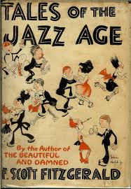 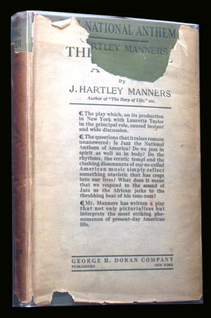

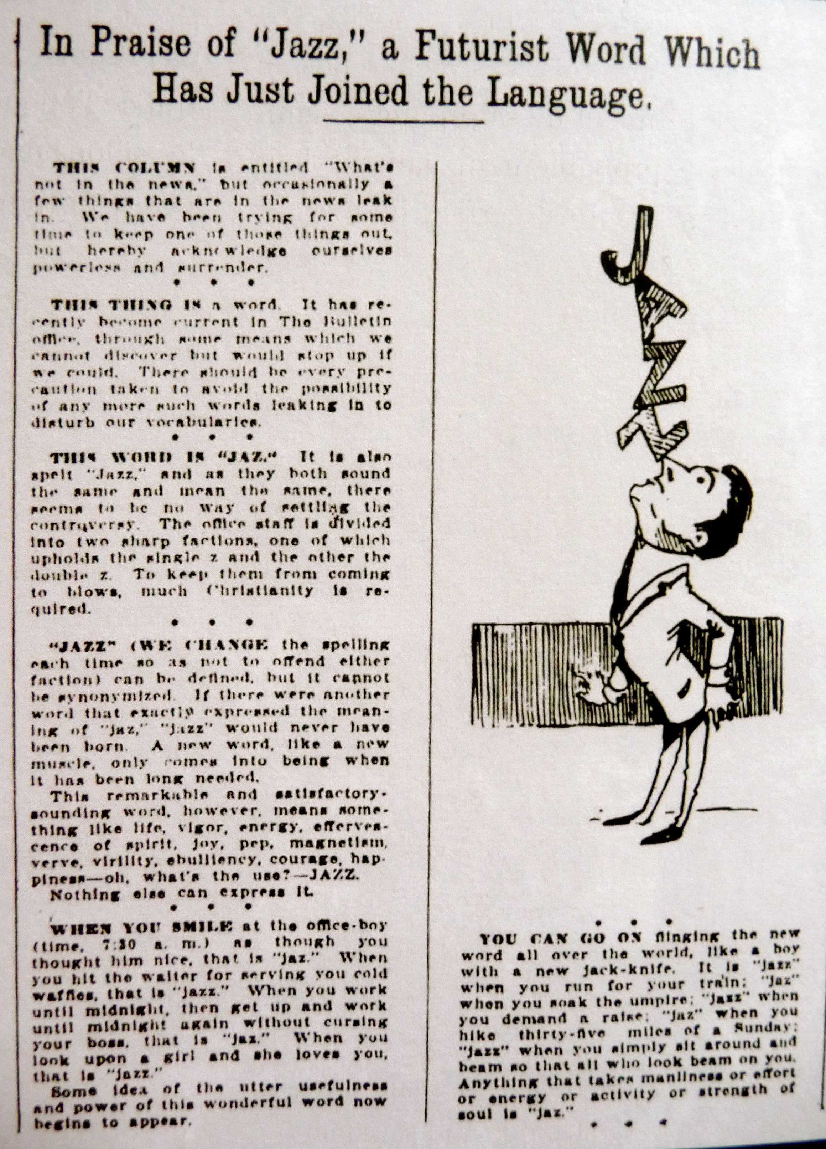

Ernest J. Hopkins, *San Francisco Bulletin* (5 April 1913)

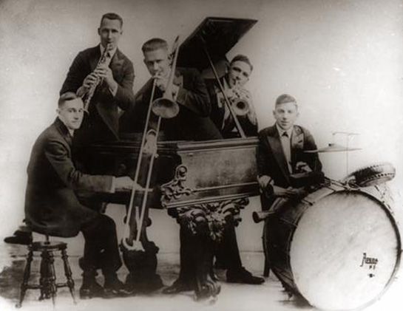

The Original Dixieland Jazz Band

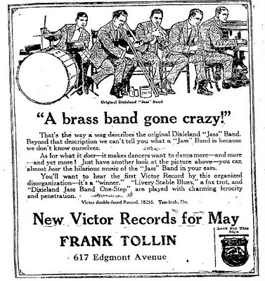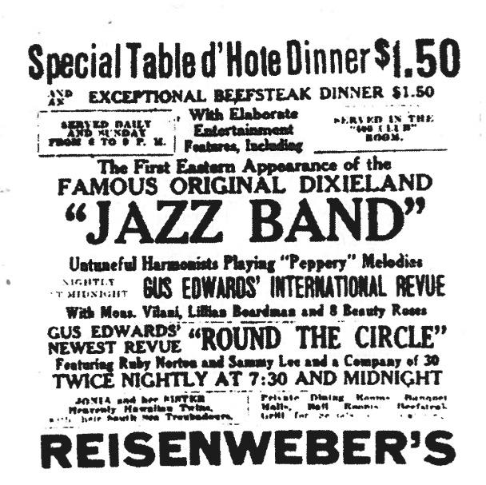

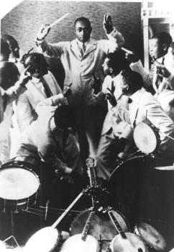

James Reese Europe & the Clef Club Orchestra

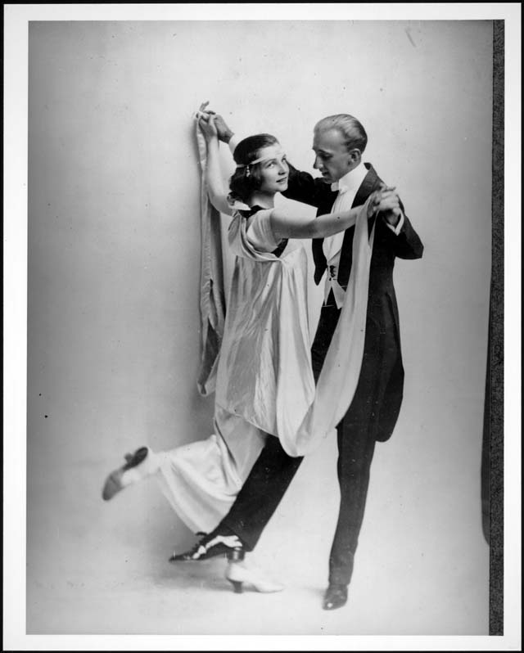

Vernon and Irene Castle

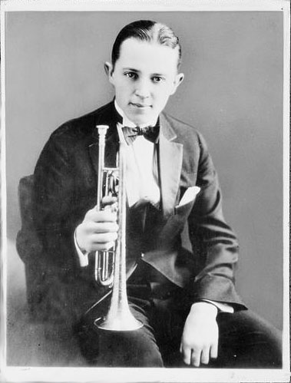

Bix Beiderbecke

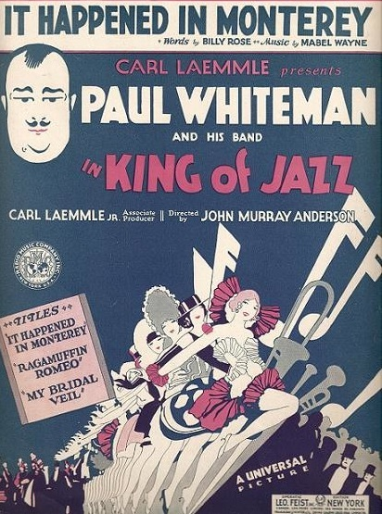

film poster, *The King of Jazz* (Universal, 1930)

